Operation helps Ronnie to walk tall (From Banbury Cake)
When It Happens Panel Get involved: send your photos, videos, news & views by texting 'OXFORD NEWS' to 80360 or email

Operation helps Ronnie to walk tall
11:00am Thursday 23rd February 2012 in Banbury By Oliver Evans
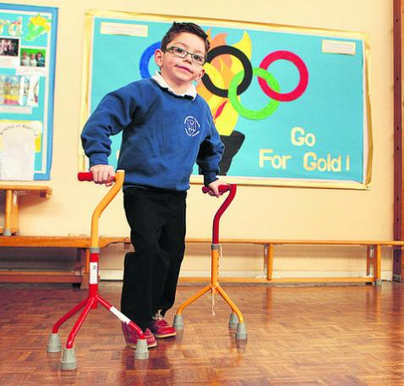Ronnie Jacobs stepping out
CEREBRAL palsy sufferer Ronnie Jacob is walking tall after kindhearted Oxfordshire people helped transform his life.
Neighbours raised £45,000 for the five-year-old to have a pioneering operation in the US in May last year to improve his mobility.
Oxfordshire charity Footsteps Foundation also provided intensive physiotherapy sessions to build on the success of the surgery.
Now Ronnie, of Park End, Bodicote, can play and join in with his friends at Christopher Rawlings Primary School in Adderbury.
Proud mum Katie said the Footstep Foundation’s work – involving a ‘Spider’ walking aid – helped turn Ronnie’s life around.
She said: “It has been marvellous. It’s not just his confidence but it’s teaching him new ways of moving which he couldn’t do before. He couldn’t sit up before or pick things up. It has been amazing.”
Life in the foundation year at school is a blast for Ronnie, who can now use crutches as well as a walking frame.
Hairdresser Katie, 30, said: “He really loves it. It means he can sit cross-legged and have stories with the rest of his friends, rather than being strapped in a chair like before.
“Over the next couple of years, fingers crossed, he will be able to do regular day-to-day activities.”
The operation, in St Louis, Missouri, severed a damaged nerve that was leading to Ronnie’s mobility problems.
Cake sales, a fashion show and parachute jumps helped raise money while dad Andrew, 43, sold his Ford Mustang car to raise £10,000.
Katie said: “Whereas he was stiff before, straight away he could open his legs and lift his knee up to his chest. He couldn’t do any of that before.”
Ronnie has attended Footsteps since he was two and has two hours of therapy a day for three weeks, six times a year.
Fiona Savory, a physiotherapist for the charity, based in Dorchester, said: “Ronnie is now able to walk with sticks unaided, something he couldn’t do before the surgery and we have been concentrating on strengthening his legs.
“He’s so much more motivated and confident, I’m having to create more and more challenges for him as he becomes more able.
“He has a great sense of humour and never fails to make me smile.”

