Residents raise £540 for children’s charity
Published 16/09/13

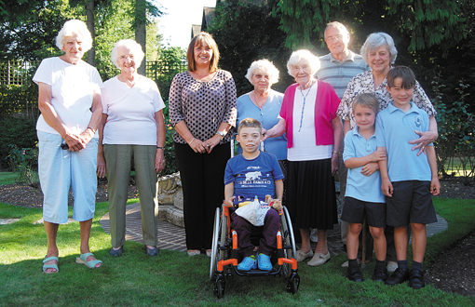
A CREAM teas event in Henley raised £540 for charity.
About 40 teas were sold at War Memorial Place in Harpsden Way in aid of the Footsteps Foundation, which provides physiotherapy for children with learning difficulties.
There was also a sale of teddy bears knitted by residents, a lucky dip of “witty knits”, including scarecrows, cowboys, cavemen and witches, a cake stall, children’s toys and books and a raffle. Children from Trinity and St Mary’s schools attended with their parents.
Mary Barker, who chairs the residents’ association, said: “It was a perfect day. We were so lucky that people could get out in the garden. At one time we seemed to have half a school out there.” The event is held every year in aid of charity and the foundation was chosen this year because it cares for children in the Henley area despite being based in Dorchester.
Mrs Barker said: “It’s not a very well-known charity. We like to support local causes rather than big charities where the money can get swallowed up.”

