GWENT NEWS
Newport man to walk around Wales to help girl take first steps
7:00am Friday 27th July 2012 in
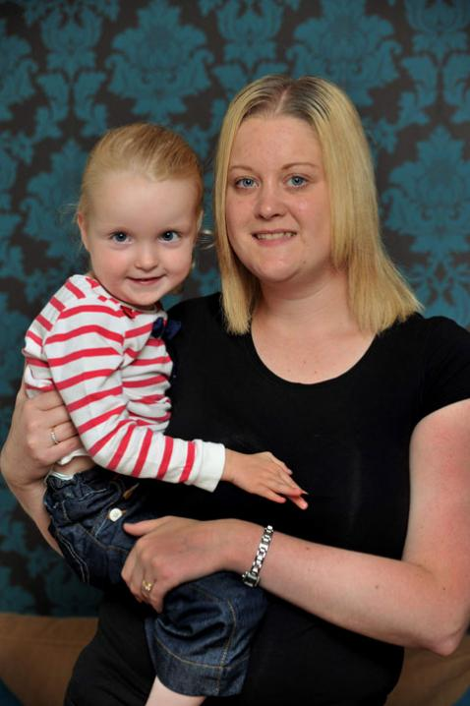
WALKING HELP: Olivia Robinson with mum Beth
A NEWPORT man will walk around Wales to raise funds to enable a three-year-old girl to take her first unaided steps.
Little Olivia Robinson from Cross Keys suffers from cerebral palsy and while she can’t even sit up unaided, physiotherapy at the Footsteps Centre in Oxford last month helped her kick a ball and walk with support in just two weeks.
However, after she returned home, the lack of continued treatment meant her muscles tightened and she was back at square one.
Her parents Daniel and Beth, both 29, are now trying to raise the £10,000-a-year cost of continued treatment at Footsteps and have set the goal of Olivia walking by the end of next year.
Inspired by the youngster, their colleague David Summers from the Office for National Statistics, sets off on a 500-mile journey around the country in September.
Olivia was born 10 weeks early and weighed just three pounds. Her dad said that like with all premature babies she had a 10 per cent chance of having cerebral palsy- from effects such as lack of oxygen to the brain.
While mentally she is fine, it became clear when she didn’t start achieving physical milestones that the premature birth had affected her ability to sit, crawl and walk. She loses her balance when sitting, with her parents saying the one-hour physiotherapy she gets on the NHS each week isn’t enough to make a meaningful impact.
After looking into various alternative therapies, they found the private Footsteps Centre in Oxford, which offers spider therapy, where a sufferer is placed in a harness on bungee cords and does different stretches and exercises such as walking on a treadmill.
The three week block last month cost £1,500, with Mrs Robinson saying: "It gave Olivia the spurt she so much needed. After only two days Olivia was kicking a ball and by the second week, walked normally, albeit supported, for the first time."
Mr Robinson added that Olivia loves the park and would "reap the benefits" of regular visits to Footsteps, where she could have two hours a day of physiotherapy in three week blocks.
They want to take her there four times next year, but estimate the cost at £10,000 with accommodation and treatment.
Mr Summers sets off on September 14, arriving home on October 8. You can donate at www.justgiving.com/footsteps-for-liv

