Miracle Offord Cluny girl Molly, 10, walking again after stroke
Written byEDWARD CURWEN
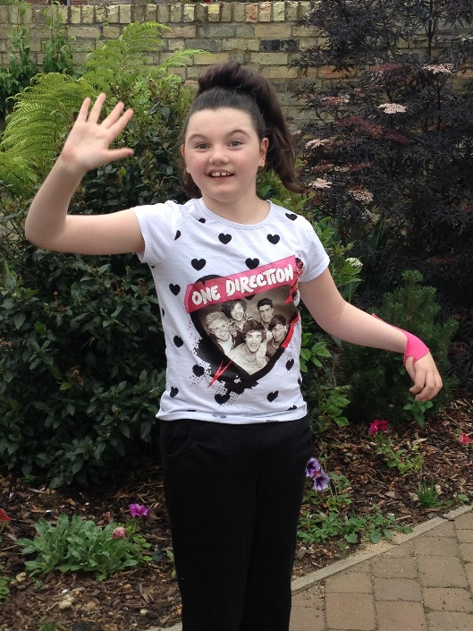

Molly Davies, 10, standing on her own two feet again

WHEN 10-year-old Molly Davies had a massive stroke in 2009, no-one was sure what the future would hold.
Unable to move, and forced to communicate with her parents by blinking, the outlook was bleak.
But her triumphant recovery continues this weekend – as she aims to walk a half-mile for charity.
Her Mum Katie Davies, 41 of Opeford Close, Offord Cluny, explained what it meant for her little girl to walk again.
She said: “For Molly, to be able to walk from the kitchen to the lounge, or across the playground to see a friends – that’s her world, that’s her independence.
“If she can walk from one room to another, that is a huge difference to her. She can remember what it was like before she got ill, she knows what it feels like to have that freedom.”
Molly took 19 tentative steps at the end of January, after some intensive physio sessions at the specialist Footsteps Centre near Oxford.
She does 45 hours every three weeks, the same amount she would do in two years on the NHS.
But the sessions cost £2,250, and Molly needs three a year.
The first was paid for by John Creek, or ‘Fatboy Swim’, who swam the channel to raise money.
And now Molly has decided that she wants to help herself.
This Sunday at Offord D’Arcy recreation ground Molly will walk a half-mile.
Molly suffers from a rare condition known as PHACE syndrome, which can show a variety of symptoms.
In Molly’s case, it is an abnormality in the blood vessels of the brain. That led to a stroke in August 2009.
It affected a small area of her brain, but it was the area of the brain that controls movement.
Initially she couldn’t move, speak, or even swallow. But, with determination, Molly is recovering.
She has returned to school and this charity half-mile is the next step in her rehabilitation.
Molly’s Mum Katie said support would be welcome at this weekend’s event: “We are trying to get other people to do it with Molly. You can cover the distance any way you like, but normal walking is not allowed.
“We’ve got three-legged, backwards, blindfolded, and someone on a space hopper.”
There will be a barbecue and a beer tent, face-painting, live music, a professional portrait photographer and a mini assault course.
The event runs from 1pm until 6pm. Molly will start her walk at 2pm. Donations can be made at www.justgiving.com/molly-will-walk-again.

