Tuesday 26 June 2012
Four-year-old close to dream of walking
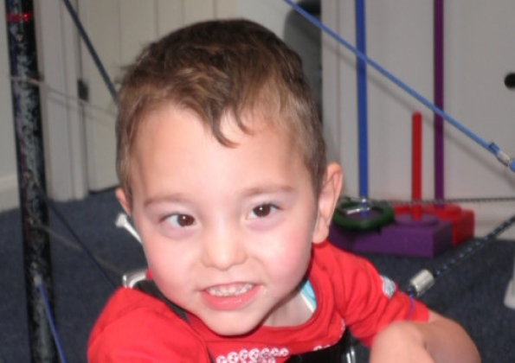
Published on Thursday 21 June 2012 13:58
LITTLE Phillip Scott is closer than ever to his dream of walking thanks to pioneering treatment.
The four-year-old, who has cerebral palsy, has just completed a three-week session of intensive treatment at a specialist physiotherapy clinic.
The therapy was paid for with the help of donations from kind-hearted Echo readers who backed our Help Phillip Walk campaign, raising more than £6,000.
Phillip’s dad Paul, 47, of Silksworth, said: “It was much better than we expected.
“We had our doubts over how he would cope with the treatment because it’s more intense than he’s used to but he did really well and seemed to enjoy it.
“We’ve already seen a difference in him as he normally curls his left hand up and fold his arm into his chest.
“Now he can open his fingers up and sit up as well, which is fantastic. They’re only small steps but we were never expecting a miracle.”
Paul and his wife Dianne have been given fresh hope by other parents they met at the Footsteps centre, in Oxfordshire.
“Every parent we met had good things to say about the centre,” Paul said.
“Not every one of them will be able to walk but the therapy has helped in some way.
“Children with cerebral palsy are in constant pain and, in a lot of cases, the treatment was able to ease the pain.
“The treatment is expensive but we are trying to do the best for our son and we feel this is the right and have been really impressed.”
The clinic recommends four sessions a year for the treatment to achieve its full potential but because it is so popular it is already booked up until next year.
Phillip will return for three weeks in January.
“We are worried about the gap in between visits but there’s nothing we can do and we’ve been given exercises to carry out until then,” Paul said.
At 10 months old, Phillip was diagnosed with a severe form of cerebral palsy which affects all his limbs, and doctors said he would never be able to walk.
In January, we launched our Help Phillip Walk campaign, urging readers to help raise cash for the youngster’s plight.
Paul and Dianne are continuing with their fund-raising drive so they can pay for Phillip to have regular treatment at the centre.
Paul added: “The money that was raised through the Echo has paid for this treatment and the next session but we still need to keep the fund-raising going.”
They have a series of events planned for this year.
Anyone wanting to help fund-raise or find out more about the Footsteps Centre can contact Paul on 1964pdpscott@live.co.uk.
Twitter: @sunechochief

