Appeal to help Leeds girl take first footsteps
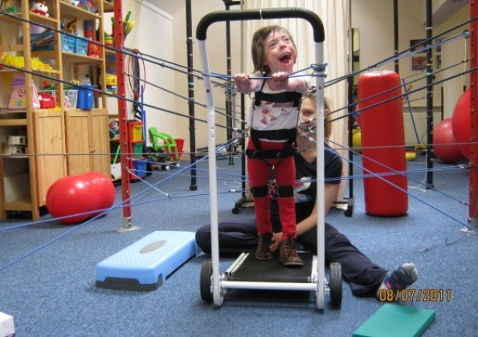
Grace at the Footsteps therapy centre in Oxford.
By Katie Baldwin
Published on Wednesday 8 February 2012 15:07
Little Grace McLoughlin is desperate to join in with her brother and sisters.
Several disabilities have left her unable to walk, sit unaided or talk, apart from with a few words.
However she has the same mental capacity as any other seven-year-old and gets frustrated when she can’t take part in the same activities.
Now her parents Daniel and Geri are hoping to raise at least £10,000 for intensive therapy could eventually allow her to communicate and walk with a frame.
Her dad, from Ireland Wood, Leeds, said: “We want Grace to achieve her full potential and we don’t know what that potential is until we push her.”
Grace was born at 26 weeks and weighed just 1lb 14lb.
“It was touch and go due to her low weight and her early birth,” said her mum, 35.
She had nine operations in her first nine months of life, spending just two weeks at home. Grace has the rare genetic condition Beckwith Wiedmann Syndrome and she was later diagnosed with chronic lung disease and severe quadriplegic cerebral palsy caused by brain damage.
She still is very susceptible to illness and needs regular kidney scans to check for potentially life-threatening tumours.
She enjoys playing with her sister Isobel, 18 months, four-year-old brother Maximo and 12-year-old step-sister Neave but she wants to do more.
“It’s so stressful, because Grace understands absolutely everything, but we cannot understand what Grace means,” her mum said.
“She can say a few words. If Max is off swimming, she says ‘and me’. Grace wants to be more able-bodied and independent.”
Her dad, 38, added: “It would mean so much if she could use a walking frame.”
Grace goes to the mainstream Ireland Wood Primary School and enjoys donkey rides at the Elisabeth Svendsen Trust in Adel.
Last summer she visited the Footsteps Centre in Oxford for three weeks of intensive physiotherapy after it was suggested as an addition to her usual treatment.
“The change in Grace last time was fantastic,” Daniel added.
However NHS funding is not available so her family have now started fundraising for two annual trips to the centre.
Activities include a bag pack at Asda in Adel on March 3. To donate, visit www.justgiving.com/Daniel-McLoughlin or for more information visit: www.wix.com/footsteps4grace/footsteps4grace

